OOP Assessment Stage 8

Now insert a ‘BUY’ button into your basket page-
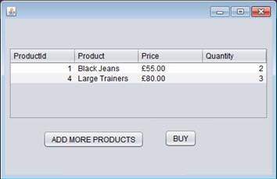

At this stage you should implement 4 things:

1) A new method within your Order class which will calculate the order total by combining the line totals for all OrderLines in your order

2) Writing Orders
You should implement the 'Buy' button so that you write your Order to the database when selected. You should write all the data to the 'Orders' table in your given database, including the 'Username' which is the Customer's unique identifier they use to login with.

3) Writing OrderLines
Ensure that when an order is written to your database (on the 'buy' button event on your Basket page) that you loop around each orderLine within that order. Inside this loop you should write out the details of each OrderLine to the database table 'OrderLines' within your supplied database.

The columns that need written to are: OrderLineId, ProductId, Quantity (note: this should be quantity from within orderLine and NOT Stock Level of Product), LineTotal and OrderId (this will be returned from the modified DBManager method which wrote the Order to database).
You should then test this to ensure it works, ensuring that the OrderLines themselves are correct and that the OrderId from the OrderLines table matches the OrderId from the Orders table.

4) You should also implement a 'Confirmation' page which is a page that is accessed directly after selecting 'Buy'. You may show any information you wish on the 'Confirmation' page.
Your 'Confirmation' page should only have 1 button- allowing the Customer to return back to the Customer Home Page.

